Study of radon dispersion in typical dwelling using CFD modeling combined with passive-active measurements

R. Rabi, L Oufni
Sultan Moulay Sliman University, Faculty of Sciences and Techniques, Department of Physics (LPM), B.P.523, 23000 Beni-Mellal, Morocco.

Abstract Inhalation of radon (²²²Rn) and its decay products are a major source of natural radiation exposure. It is known from recent surveys in many countries that radon and its progeny contribute significantly to total inhalation dose and it is fairly established that radon when inhaled in large quantity causes lung disorder. Indoor air conditions and ventilation systems strongly influence the indoor radon concentrations. This study focuses on investigating both numerically and experimentally the influence of environmental conditions on the indoor radon concentration and spatial distribution. The numerical results showed that ventilation rate, temperature and humidity have significant impacts on both radon content and distribution. The variations of radon concentration with the ventilation, temperature and relative humidity are discussed. Minimum radon levels were estimated in this case study at the temperature of 15° C and relative humidity between 50-70%.

Keywords: Radon, SSNTD, Exhalation rate, Computational Fluid Dynamics (CFD), Measurement method, Analytical method.

Introduction
Study of radon and its progeny in air is indispensable, as these deliver the highest radiation dose to human beings among all natural radioactive sources. It has been estimated that inhalation of short-lived radon progeny accounts for more than half of the effective dose from natural sources (Singh et al. 2005). Therefore, knowledge of ²²²Rn and its progeny concentration in indoor and outdoor environment is important to estimate the inhalation dose to the population of the region. Studies are also needed to understand the dependence of ²²²Rn and its progeny concentration on ventilation, temperature, humidity and other environmental parameters.
In recent time, Computational Fluid Dynamics (CFD) has taken outstanding position for simulation of indoor radon problems ( Lee et al. 2016; Rabi and Oufni 2016). However, these studies do not explain how physical and environmental factors affect indoor radon concentration. The present study considers different indoor temperature and humidity conditions, ventilation rates, and other possibly important parameters to determine their effects on indoor distribution of radon concentration.

Physical model
The studied model house plan is illustrated in Fig. 1. It occupies a surface of 100 m² (10 m long by 10 m wide and 3 m high). It consists of a living room of 28 m² in surface, two bedrooms each one has 20 m² in surface, a kitchen of 12 m² in surface, bathroom and restroom each one has surface 2 m². The house is oriented west-east, the walls west and east are facing outdoors, each of the outer walls has two windows, while the other two sides (north and south) have no windows. Thus, the ventilation in the house is provided by two windows in west wall, those are open, and the air exits are across two windows of east wall.
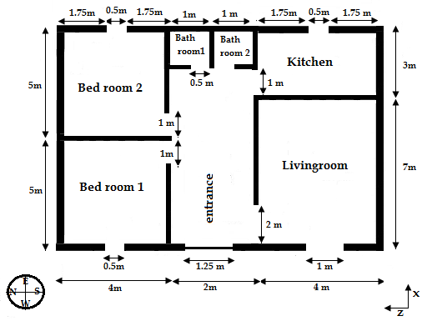
Fig. 1. The configuration of the house

The numerical method
The classical mass, momentum, energy, radon concentration and humidity equations can be represented for a steady-state, three-dimensional flow with the following conservation equation:
$$\frac{∂ϕ}{∂t}+\frac{∂}{∂x_{i}}\left(u_{i}ϕ\right)=\frac{∂}{∂x_{i}}\left(Γ_{ϕ}\frac{∂ϕ}{∂x_{j}}\right)+S_{ϕ} (1)$$
where $ϕ$ stands for the variables of interest, i.e. the three velocity components u_{i} (m s⁻¹), the temperature T (K), the radon concentration and the specific humidity. $Γ_{ϕ}$ and $S_{ϕ}$ represent the diffusion coefficient and source term of $ϕ$, respectively.
The system of equations built with these variables is numerically solved with the finite volume method. To model of the turbulent constraints, we have using the standard k–$ε$ turbulence model in Eq.(1), with $ϕ$ represents the turbulent kinetic energy k (m² s⁻²) and the dissipation rate of turbulent kinetic energy $ε$ (m² s⁻³).
The Boussinesq model was also activated to take account of the gravity effect, which means that the buoyancy force due to air density differences is added as a source term of the momentum equation.

Results and discussion

Ventilation effect

In order to investigate the effect of ventilation on indoor radon concentration, two conditions were taken; the first is devoted to a house with all the windows are closed (which is the case of the cold season) and the second treats the opening effect of windows for a good natural ventilation (which is the case in the summer season).
Figures 2 and 3 illustrate the contours of radon concentration in the house plan at position y=1.50 m from the floor for the two cases studied. It can be noticed from these figures that the ventilation has distinct effect on radon concentration in all the rooms in the house. The airflow velocity profile as shown in Fig. 4.

Fig. 2 Contours of radon concentration (Bqm⁻³) in closed house at plane (Y =1.50 m)

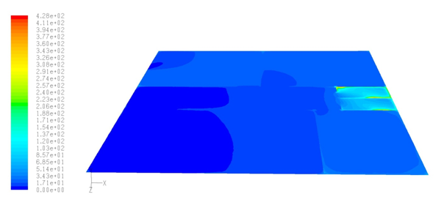
Fig. 3. Contours of radon concentration (Bqm⁻³) in open house at plane (Y =1.50 m)

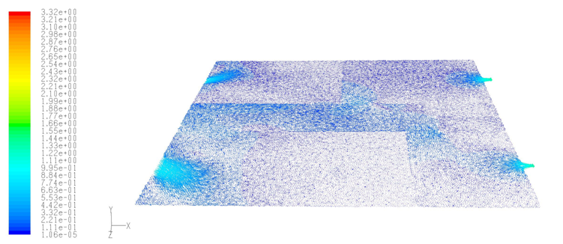
Fig.4. Velocity streamline of the air flow in open house at plane (Y =1.50 m)

References:
Singh K, Singh M, Singh S, Sahota HS, Papp Z (2005) Variation of radon (²²²Rn) progeny concentrations in outdoor air as a function of time, temperature and relative humidity. J Environ Radioact 39(2005): 213 – 217. doi: 10.1016/j.radmeas.2004.06.015
Lee JE, Park HC, Choi HS, Cho SY, Jeong TY, Roh SC (2016) A numerical study on the performance evaluation of ventilation systems for indoor radon reduction. Korean J Chem Eng 33(3): 782–794. doi:10.1007/s11814-015-0214-8.

Rabi R, Oufni L (2016) A theoretical investigation of the distribution of indoor radon concentrations. Indian J Phys: 1–9. doi:10.1007/s12648-016-0932-8

